# Translations Builder User Guide

Translations Builder is an external tool created for Power BI Desktop specifically to assist report authors and dataset authors with tasks associated with creating translations and building multi-language reports. As a user, you can install Translations Builder and use it together with Power BI Desktop to build and test datasets and reports that support multiple languages.

There are three types of translations that come into play when localizing Power BI datasets and building reports that support multiple languages. Translations Builder helps to create and manage the first two types of translations which are **metadata translations** and **report label translations**. Translations Builder does not provide any assistance with implementing **data translations**. For more background on this topic, please read [Understanding the Three Types of Translations](https://github.com/PowerBiDevCamp/TranslationsBuilder/blob/main/Docs/Building%20Multi-language%20Reports%20in%20Power%20BI.md#understanding-the-three-types-of-translations).

While this document has been designed to explain the features and limitations of Translations Builder, it is recommended that you additionally read through the [guidance document](https://github.com/PowerBiDevCamp/TranslationsBuilder/blob/main/Docs/Building%20Multi-language%20Reports%20in%20Power%20BI.md) and work through the [hands-on lab exercises](https://github.com/PowerBiDevCamp/TranslationsBuilder/blob/main/Labs/Hands-on%20Lab%20-%20Building%20Multi-language%20Reports%20for%20Power%20BI.md). They will provide a great compliment for the contents you’ll find here.

### Limitations

This

#### Supported Languages and Locales

When the Power BI Service loads a report, it creates a user context that includes a language ID and a locale identifier. The Power BI Service parses the language ID and the locale identifier together into string-based value known as the culture identifier. For example, a culture identifier of **en-US** represents a user who speaks English (**en**) in the United States (**US**). A culture identifier of **fr-FR** represents a user who speaks French (**fr**) in the France (**FR**).

Translations Builder supports the following set of languages.

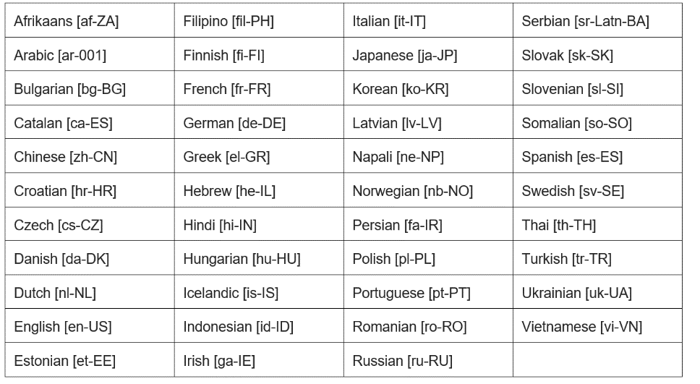

|  |  |  |  |
| --- | --- | --- | --- |
| Afrikaans [af-ZA] | Filipino [fil-PH] | Italian [it-IT] | Serbian [sr-Latn-BA] |
| Arabic [ar-001] | **Finnish [fi-FI]** | **Japanese [ja-JP]** | **Slovak [sk-SK]** |
| Bulgarian [bg-BG] | **French [fr-FR]** | **Korean [ko-KR]** | **Slovenian [sl-SI]** |
| Catalan [ca-ES] | **German [de-DE]** | **Latvian [lv-LV]** | **Somalian [so-SO]** |
| Chinese [zh-CN] | **Greek [el-GR]** | **Napali [ne-NP]** | **Spanish [es-ES]** |
| Croatian [hr-HR] | **Hebrew [he-IL]** | **Norwegian [nb-NO]** | **Swedish [sv-SE]** |
| Czech [cs-CZ] | **Hindi [hi-IN]** | **Persian [fa-IR]** | **Thai [th-TH]** |
| Danish [da-DK] | **Hungarian [hu-HU]** | **Polish [pl-PL]** | **Turkish [tr-TR]** |
| Dutch [nl-NL] | **Icelandic [is-IS]** | **Portuguese [pt-PT]** | **Ukrainian [uk-UA]** |
| English [en-US] | **Indonesian [id-ID]** | **Romanian [ro-RO]** | **Vietnamese [vi-VN]** |
| Estonian [et-EE] | **Irish [ga-IE]** | **Russian [ru-RU]** |  |

While Translations Builder supports these 43 languages, it is important to understand that it only supports a single culture identifier for each language. For example, you can add the language **Spanish [es-ES]** to your PBIX project. But you cannot add the language Spanish with the culture identifier for a different locale such as **es-MX** for Spanish in Mexico.

Even if you intend to build Multi-language reports for users who speak Spanish in Mexico, you have to add the language as **Spanish [es-ES]**. However, you can still load reports with a cultural identifier of **es-MX**. The DAX code generated by Translations Builder to implement report label translation only uses the first part of the culture identifier.

For any project that requires English, you must add the language as **English [en-US]**. For any project that requires French, you must add the language as **French [fr-FR]**. For any project that requires Portuguese, you must add the language as Portuguese **[pt-PT]** and so on.

#### Import and Export using CSV Formatted Files

ddddd

#### Translations Buread ilder Configuration Options

Inbox/Outbox to facilitate workflows associated with gathering and integrating human translations

Adding a Key and Location for the Machine Translator Service

### Adding Metadata Translations

#### Adding Secondary Languages

Remember that calling **SaveChanges** doesn't update the PBIX project file. After making changes to a dataset using an external tool such as **TranslationsBuilder**, you still need to return to Power BI Desktop and save your changes there. OK, now you’ve been told several times to save your changes in Power BI Desktop. This is your last warning.

#### Creating and Editing Translations by Hand

Remember that calling **SaveChanges** doesn't update the PBIX project file. After making changes to a dataset using an external tool such as **TranslationsBuilder**, you still need to return to Power BI Desktop and save your changes there. OK, now you’ve been told several times to save your changes in Power BI Desktop. This is your last warning.

#### Testing Metadata Translations in the Power BI Service

#### Creating Machine Translations using the Azure Translation Service

### Adding Report Label Translations

#### Creating the Localized Labels Table

Show command to create table

Create simple label

Show behind the scenes what has been created

Delete all and add multiple labels at once

Import labels from a file

#### Generating the Translated Localized Labels Table

Show command.

Show the two tables behind the scenes.

While the Localized Labels table is hidden from report authors, the Translated Localized Labels table is not hidden. That is what report authors use to create translated report labels

#### Surfacing Localized Labels on a Power BI Report

Measure make life easy. Over the last two years, Power BI Desktop has been extended

* Card visual
* Shape such as a Rectangle
* Button

### Adding Data Translations

When implementing metadata translations and report label translations, Translations Builder can automate a large percentage of the translations work that need to be done. Unfortunately, the same is not true for data translations. Implementing data translations will often require refactoring the underlying database or datasource to provide extra columns to provide translations on a row to row basis.

#### Understanding Translations Builder Support for Data Translations